

32 inchs Touch Digital Kiosk With Pedestal

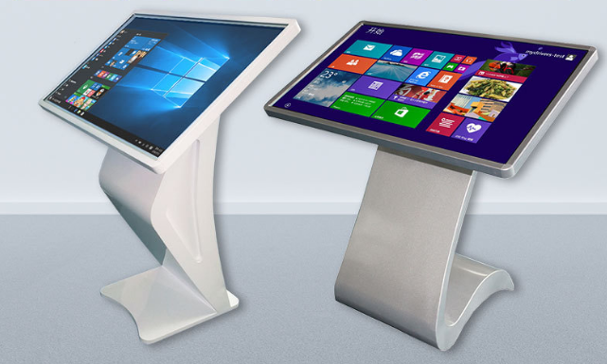

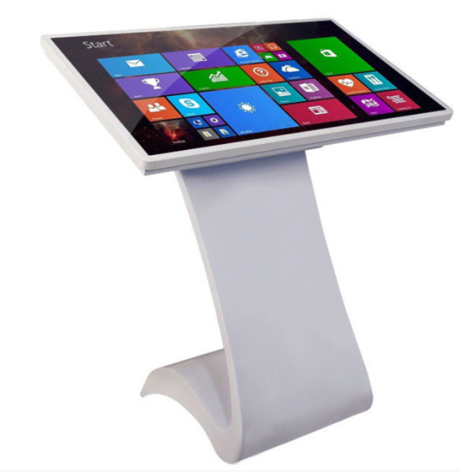
Specifications

Operating system
Windows,Core i5 4th,4GB +128GB
Touch control
10-point touch scren, faster response, smooth operation
Cloud intelligent management system
Centralized control of multiple equipments through network, saving your time
Time management system
Time on/ off at will by romote control system

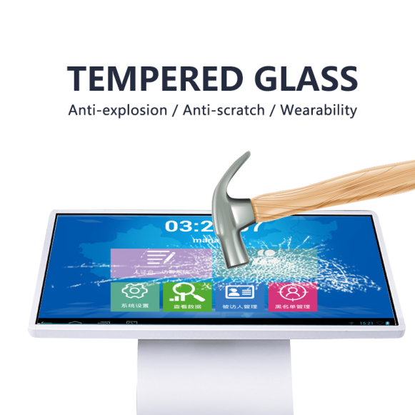
Multiple protection

Anti-explosion
Anti-scratch
Wearability

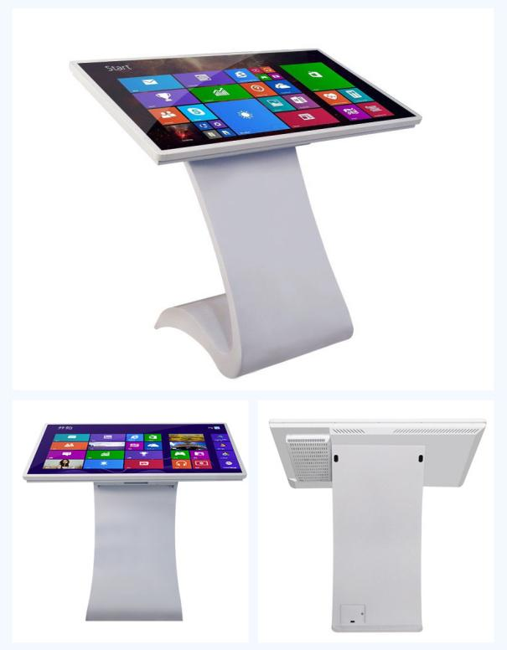

Features
Improve customer experience
By reducing waiting times, and providing real-time information as a self-service option
Free up resources
Diminish the pressure on your staff and free up their time to work on critical workload
Provide 24/7 service
Information kiosks operate 24/7, ensuring customer engagement at all times
Reduce ongoing costs
Reduce your operational overheads on an ongoing basis

Pedestal

Multiple-pedestal for your selection

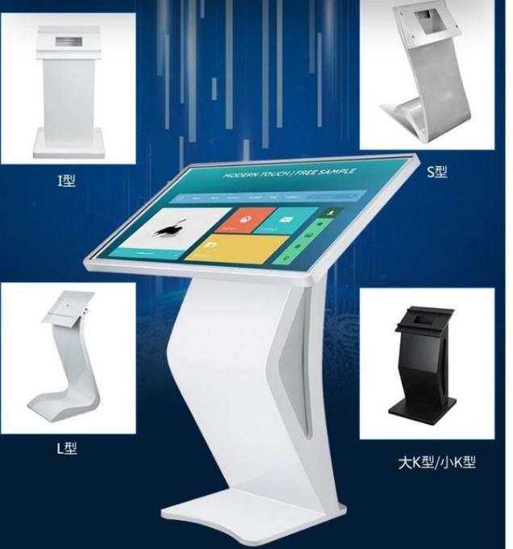
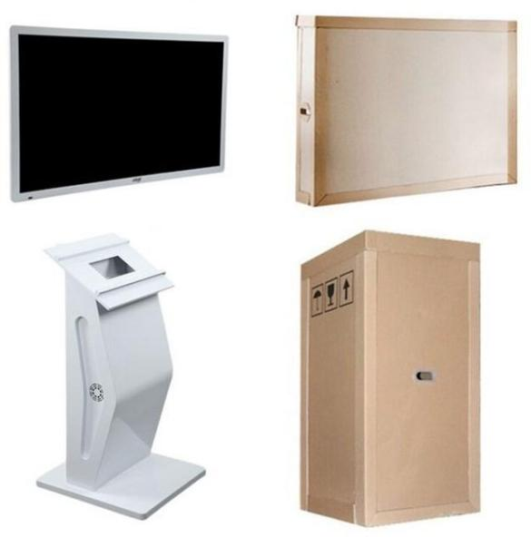

Packaging

The LCD signage and the pedestal are individually packaged to reduce freight and ensure transportation safety

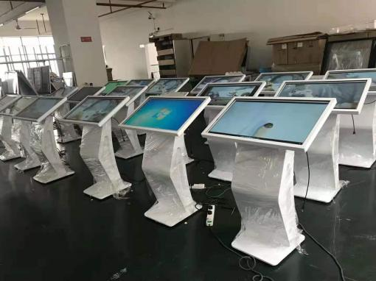
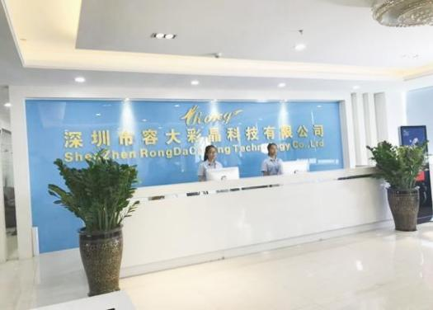
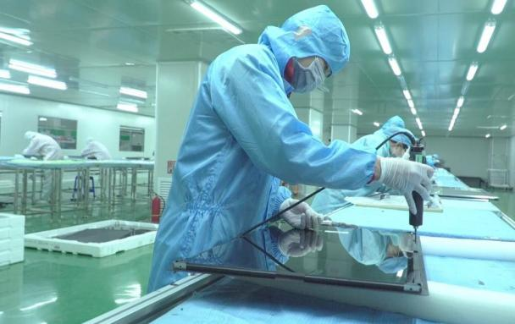

About us
Has been specializing commercial display since 2011 in Shenzhen in south China
Cover 12000m², 5 wholly-owned subsidiaries, two production bases with 100,000 level dust-free workshop and multple automated assembly lines
Elected as “Vice President Unit Of Shenzhen Commercial LCD Display” , “2015 Excellent Brand of Lcd Advertising Machine”, “Golden Peacock Award”

Item | Name | 32 inchs Touch Digital Kiosk With Pedestal
Motherboard | OS | Android
Motherboard | CPU | RK3566
Motherboard | RAM | 2GB
Motherboard | HDD | 16GB
Motherboard | Network | RJ45/WiFi/Bluetooth/Extensible 3G、4G
Motherboard | Interface | (Peripherals)USB×2、 (Internal)USB8×4、TF×1、 RJ45×1、 LVDS×1、 HDMI×1、RS232×4
LCD | LCD panel | Brand new LG/ AUO/ BOE/ CSOT LCD panel
LCD | Display area(mm) | 714(H)*411(V)MM
LCD | Display ratio | 16:9
LCD | Brightness | 300cd/㎡
LCD | Contrast | 1300：1
LCD | Viewing angle | 178°(V)/ 178°(H)
LCD | Resolution | 1920x1080
LCD | Touch screen | Multiple-point infrared touch
Support format | OS Version | Android 7.1.2
Support format | Language | Multi-language
Support format | Video formats | RM/RMVB，MKV，TS，FLV，AVI，VOB，MOV，WMV，MP4
Support format | Audio formats | MP3，WMA，WAV，AC3，FLAC
Support format | Image formats | BMP/PNG/GIF/JPEG
Support format | Other | PDF、PPT、SWF text、Real-time data stream
Support format | System management | management, group management, multi-user management, remote management, timing switch
Body | Body color | Black + silver/custom
Body | Material | Toughened glass + sheet metal + aluminum profiles
Body | Installation | Floor standing
Body | Tempered | 3mm
Others | Working power | ≤60W
Others | Life span（hrs） | ≥50,000hrs
Others | Working temperature | 0~50℃
Others | Storage temperature | -20~60℃
Others | Working humidity | 5% ~ 90%
Others | Store humidity | 5% ~ 90%
Size+weight | lcd size+lcd weight | 749.7*444.3*65MM(L*W*T),12.5KG
Size+weight | Base size+base weight | 1028*433*376mm+6.4KG

